Centralizing

<https://css-tricks.com/quick-css-trick-how-to-center-an-object-exactly-in-the-center/>

I was creating a formulary page just to train my knowledge using bootstrap’s classes. Then I thought about inserting a “pop-up error message”, that should be fixed in the top, and also centralized.

#alert-error{

position: fixed;

top: 0;

width: 80%}

But by default, the div was being fixed in the left margin too, and no ”left:50%;”, was helping…

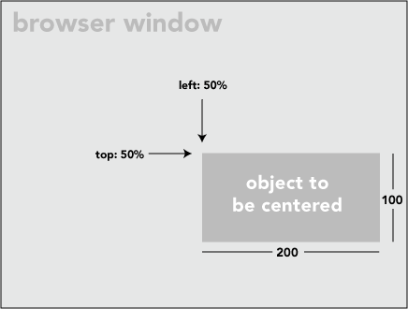

The left corner works as the referenced point that’s centralizes, and not the entire div itself. So to resolve this problem I asked some help to my teacher Google, and then, he respond me in less then 0.37 seconds, with an amazing article in the wonderful css-tricks.

I took their code and adapted to my situation, so there it is:

#alert-error{

position: fixed;

top: 0;

left: 50%;

transform: translate(-50%);

width: 80%;

z-index: 50;

text-align: center;}

